**In other to access all those pages please make sure your internet is on as it has external plugins like font awesome, which may not load. And please make sure the font awesome is load fully and display in the menu bar**

This is an educational websites, aimed to teach technology to student all over the world not matter where you are.

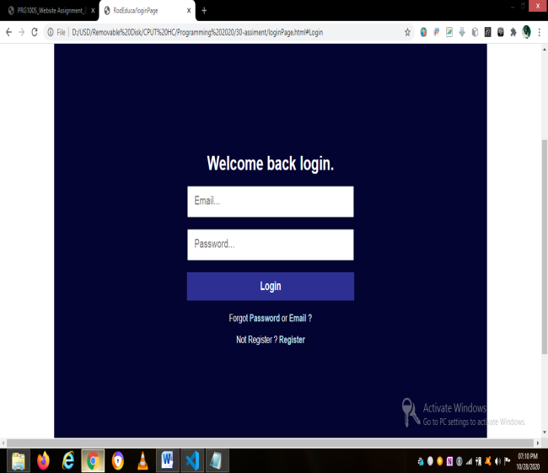 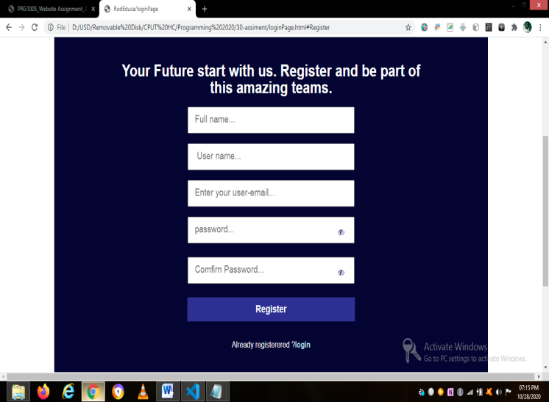

At first the user need to register **before** login. After filling their information in the textboxes, they will be able to view their information when the press the register button. The provider information must be correct as it is when filling the log in form. If the information is not correct the user will be alerted to fill the correct information. Else if it is correct, the user going to automatically be send in the home page, which is after two seconds.

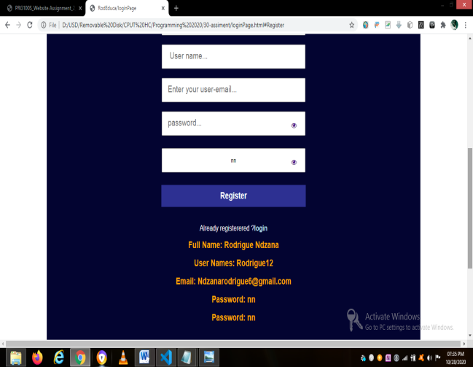 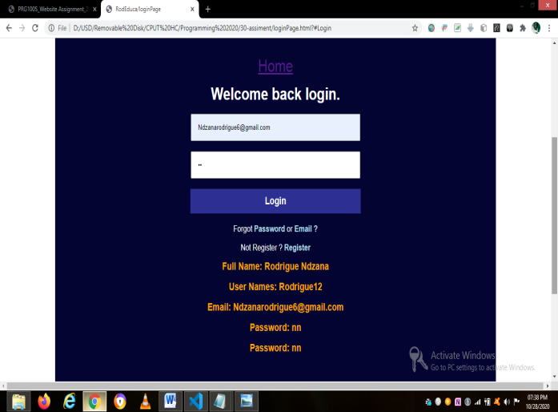

After clicking Home in the login page, user will be send to the home page which is the image below. All **links** in the Home page **are internal links** (meaning it will only take you to pages **within** the home page). If you want to go to an **external page** like **courses**, you must click courses in the home page them it will take you to the courses session. In the courses session there is a button like **find more courses**, this button them will take you to an external page where there is courses. All internal pages have the button that will take you to an external page. An example is shown in the image on the left. The Get started button will take you to the contact page. But clicking the contact link in the home page, it will take you to the footer and in the footer click any contact us link.

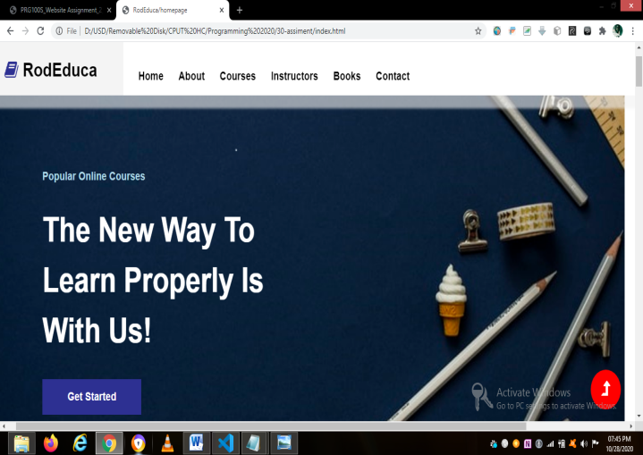 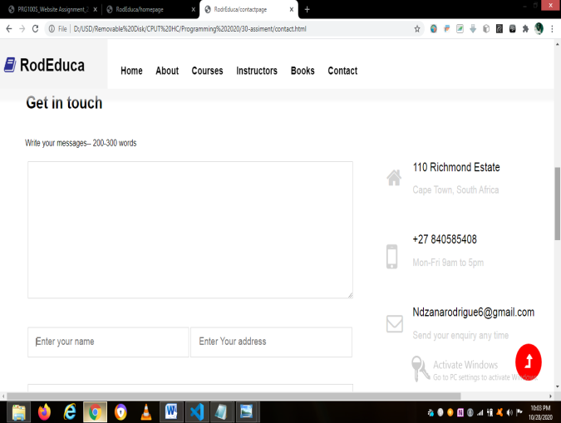

**Home**  **External contact us pages**

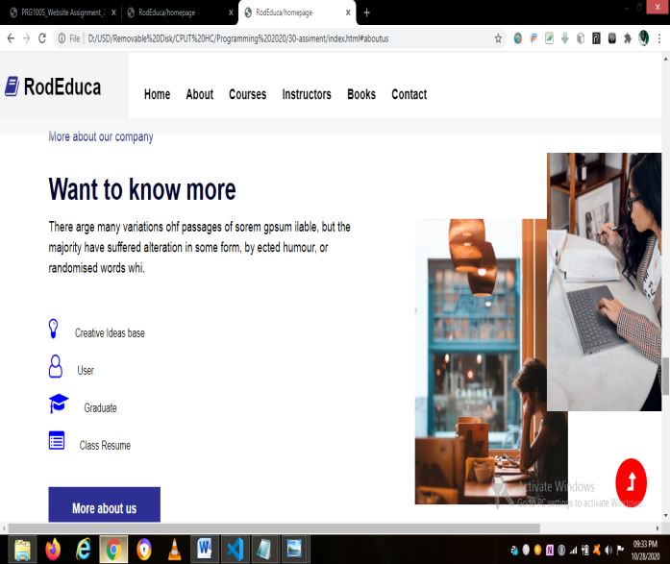 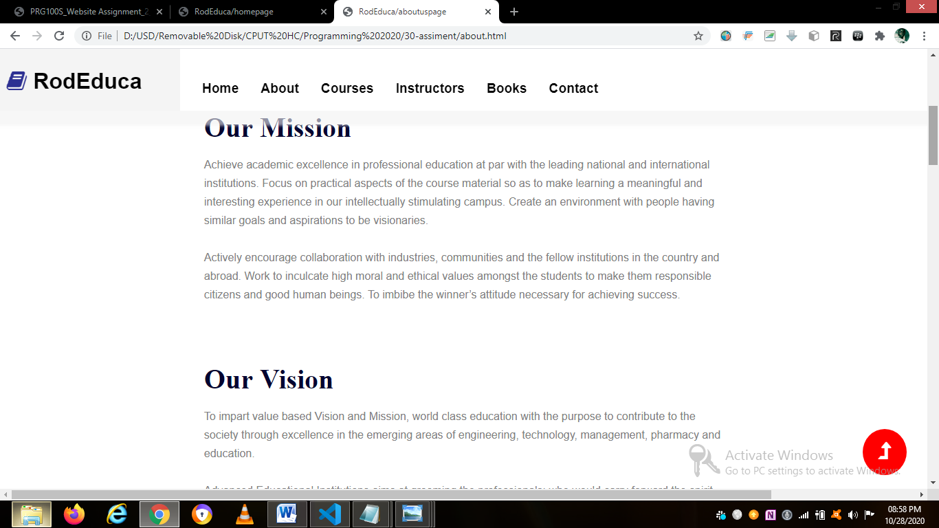

**Internal** **About us page External** **About us page**

The above pages is an about us page. This page will allow the users to learn more about the institute or company as the shared the vision and mission of the company. In addition, this page also has feedback from other graduate that study with RodEduca, by clicking the “new feedback” button, you will be able to view other feedback.

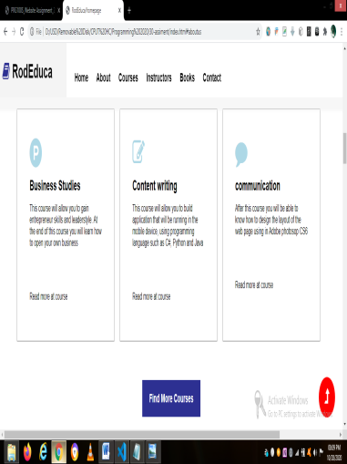 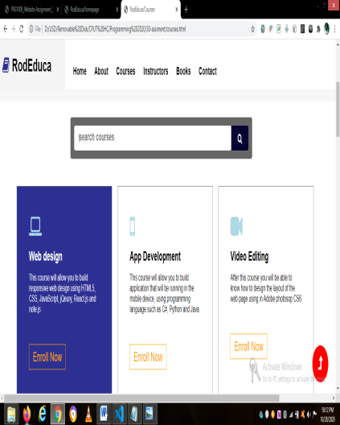 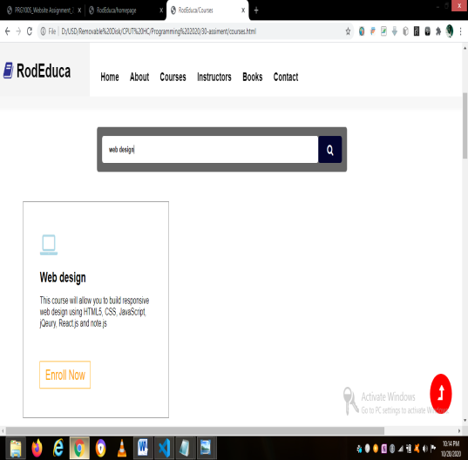

**Internal page Courses page Course search bar functionality page**

This page will allow user to enroll for a specific course, and get notify when the enroll. Users can also search for a course by tying the name of the course in the search bar which will filter and display element in that specific div.

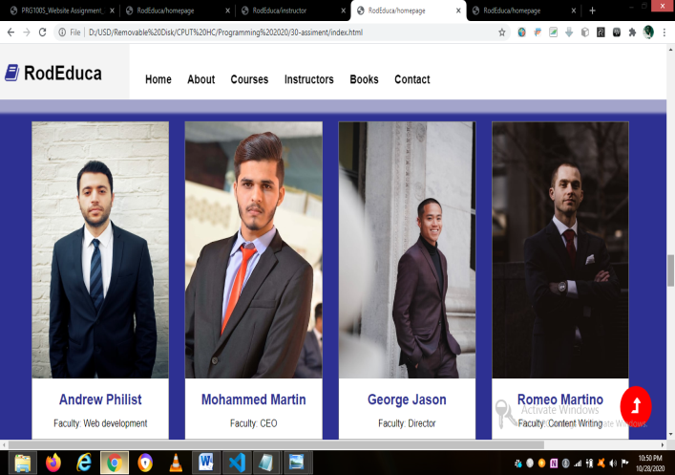 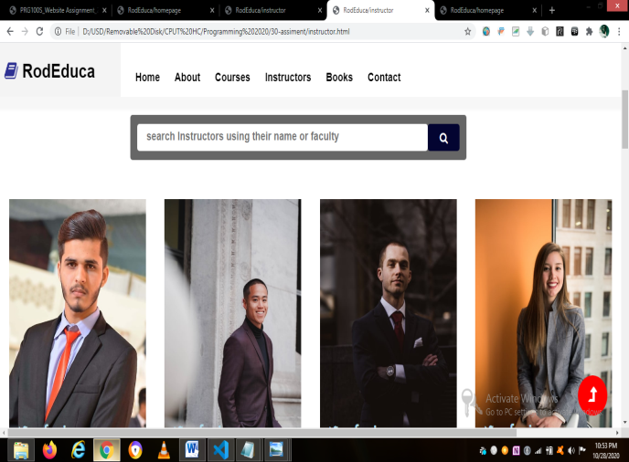

**Internal instructor or faculty page External instructor or faculty page**

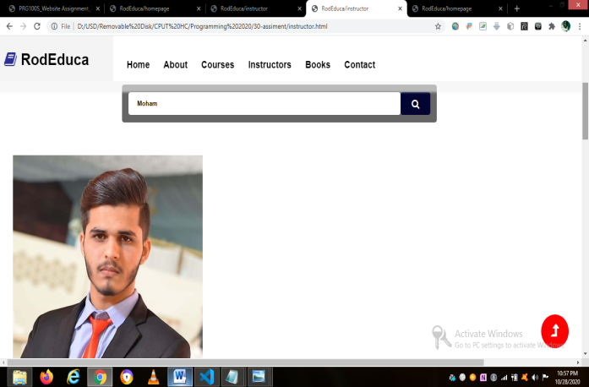 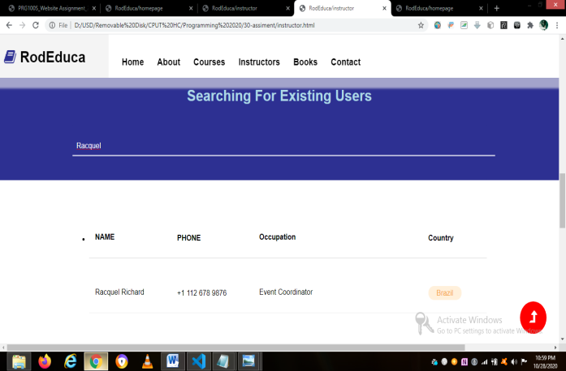

**Search functionality faculty Search existing user faculty**

The instructor or faculty page allow user to ***search for a faculty*** by tying his or her name or faculty position (e.g CEO) in the search bar as shown above (Search functionality faculty). When I type “Mohammed, I am only getting Mohammed from all people and his information. In addition, you can also **search for existing users** such as graduate which had study before or has register with us, by going to a list of people and search type the name you would like to search.

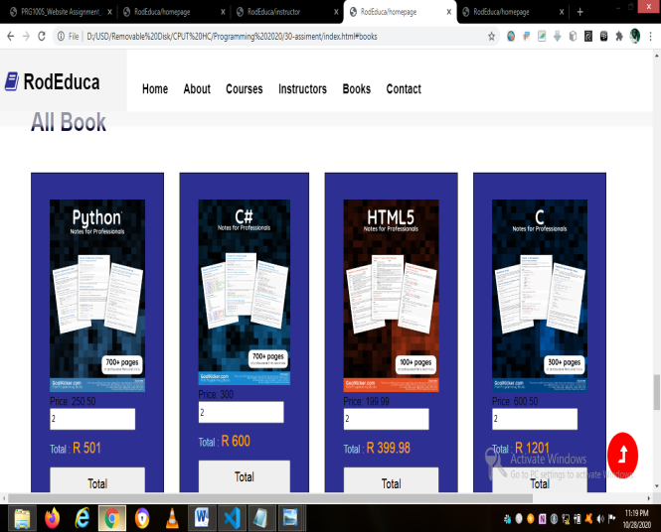 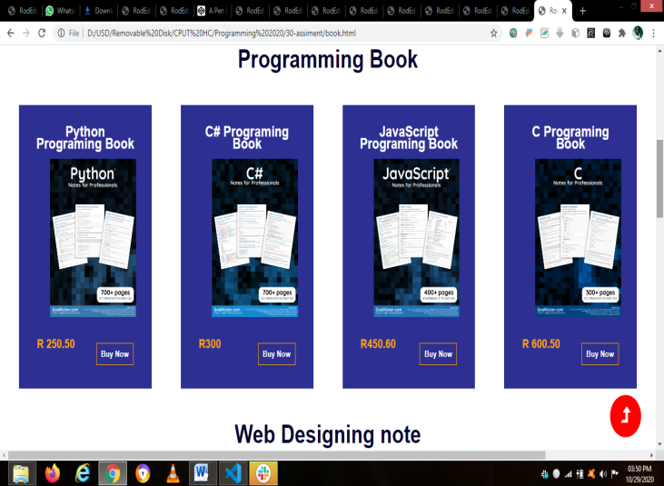

**Internal book page with the total button External book page with the add to cart button**

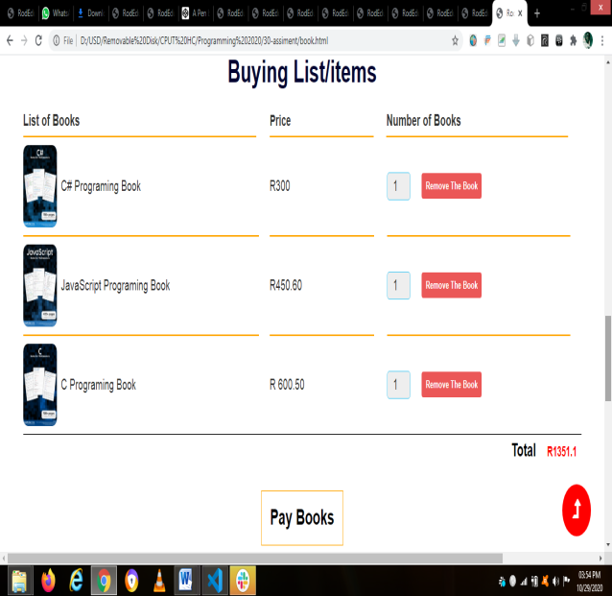 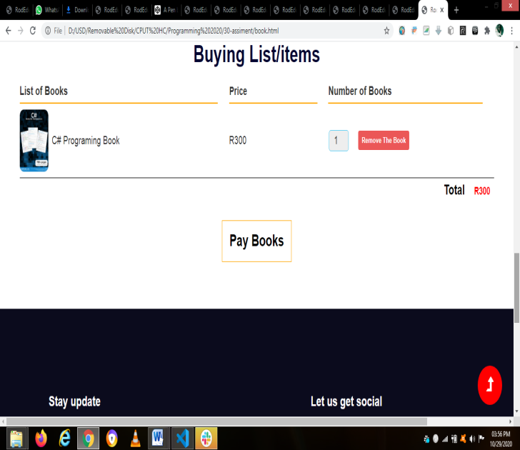

**Add to Cart functionally**  **Remove items in the cart functionality**

The Book session of the page it more likes a shopping cart. It was designed for those who will like to purchase a book to read at home or anywhere else. In this page user can add items in the cart, remove items in the cart and increase the number of quantity (how many book they would like to purchase).

If the users purchase an items that is already in the shopping cart, they going to get an alert that the items has already been purchase, as soon as the items is purchase or removes from the cart, the total get update, in which I call the update function in the both remove and add event listener function to trigger the event. After selecting all items the user would like to purchase, he can them click the purchase book items. By doing that he will get an alert thanking him/her for purchasing with RodEduca. And all items will be remove and the cart will be empty.

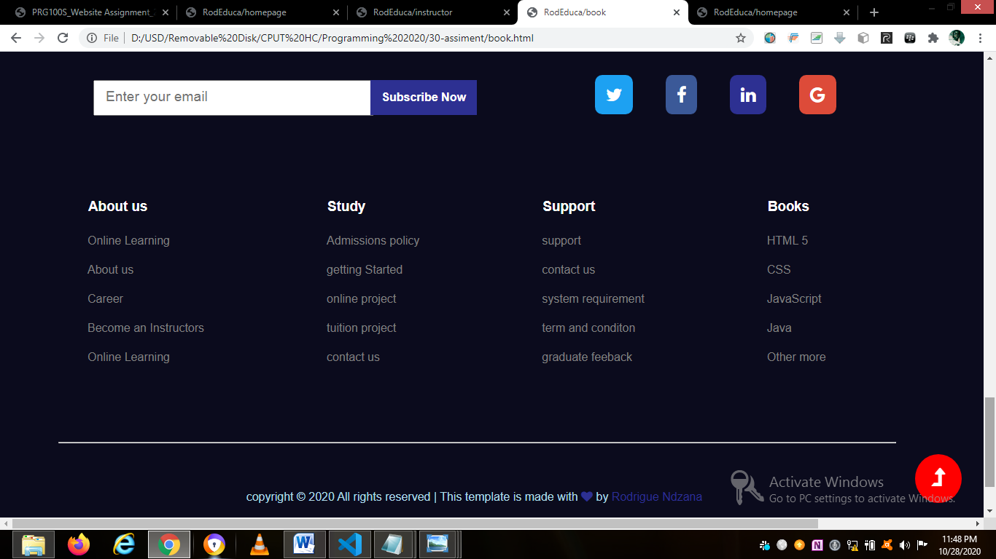

The footer of the user…. NB- **All link there are not working** except **contact us**; which will send the user to the **contact us form**. Those link were just added there for designing purposes.